|  |
| --- |
| Circle Language Spec: Execution Control |

## Until in a Diagram

The concept of the Until loop is already covered by the article *Until*. This article only explains its expression in a diagram.

Below is an example of the diagrammatic expression of a Until loop.

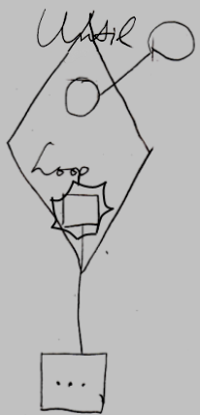

The diamond is a call to the Until command. There is a circle inside the diamond, that represents the Boolean Condition. The name Condition is not shown with the circle, because it is the only circle there and it looks so obvious that it is the condition. The circle inside the diamond points to another circle outside the diamond, indicating that the Boolean is defined outside the call to the Until statement. The diamond also contains a square called Loop, which is a reference to the command, that will be run as long as the condition is False. The Loop command reference points out of the diamond to a command defined outside the call to the While statement.

The Loop parameter is placed inside a nonagon purely for esteatic reasons. It is a single reference to a command, and the nonagon will never contain multiple references to commands, but it is obvious the command in it will be run multiple times. The nonagon stands for multiple, so it is put around the Loop parameter, but it will always contain a single item and you cannot add any more items to it.

In the example above, the Condition and the Loop procedure reference were defined outside the diamond. They may as well have been defined right inside the diamond. The diagram above is just an example.

The *definition* of the Until execution control command is part of a system module for execution control commands. The public elements of the definition look like this:

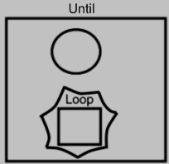

Nothing is filled in yet as the Condition or the Loop procedure reference.